***The total amount spent and the country for the Pending delivery status for each country.***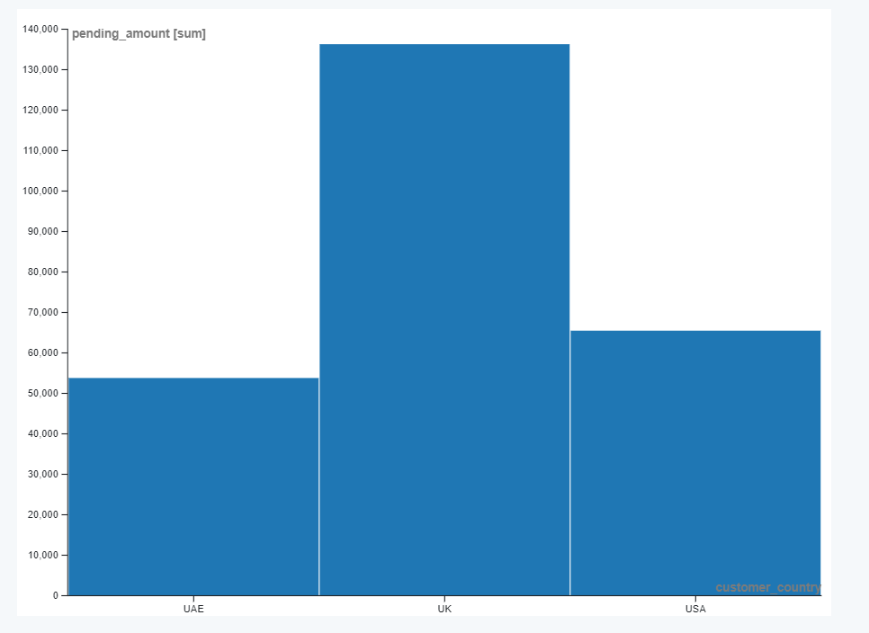

***The maximum product purchased for each country.***

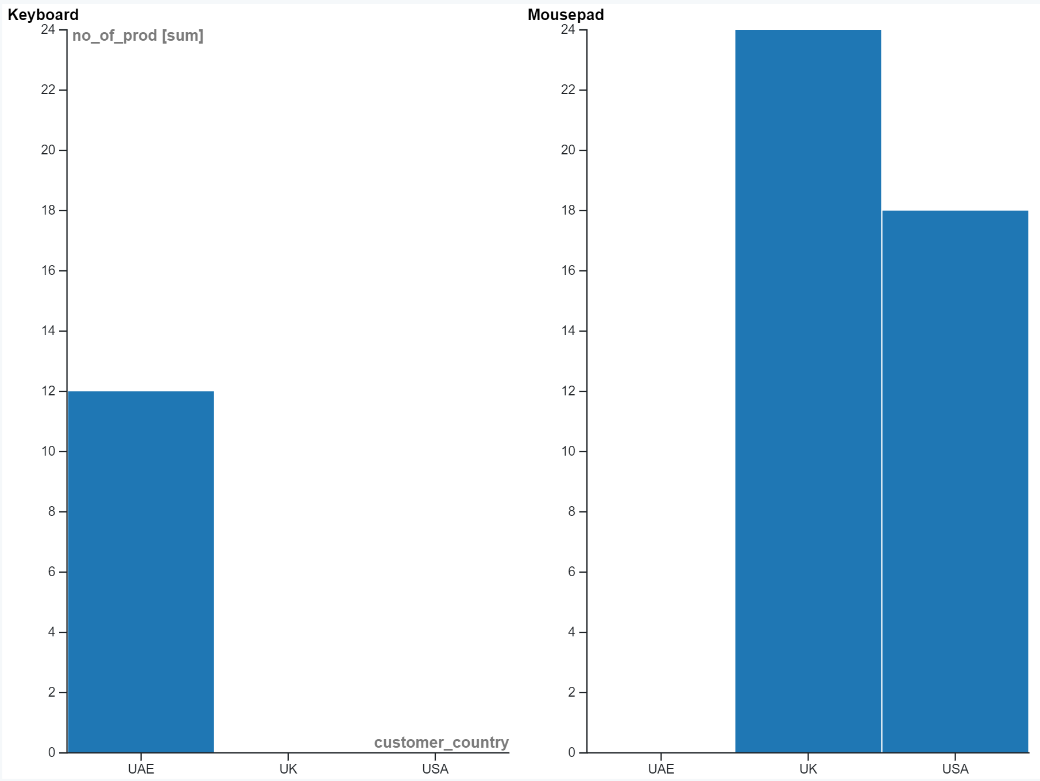

***The most purchased product based on the age category less than 30 and above 30.***

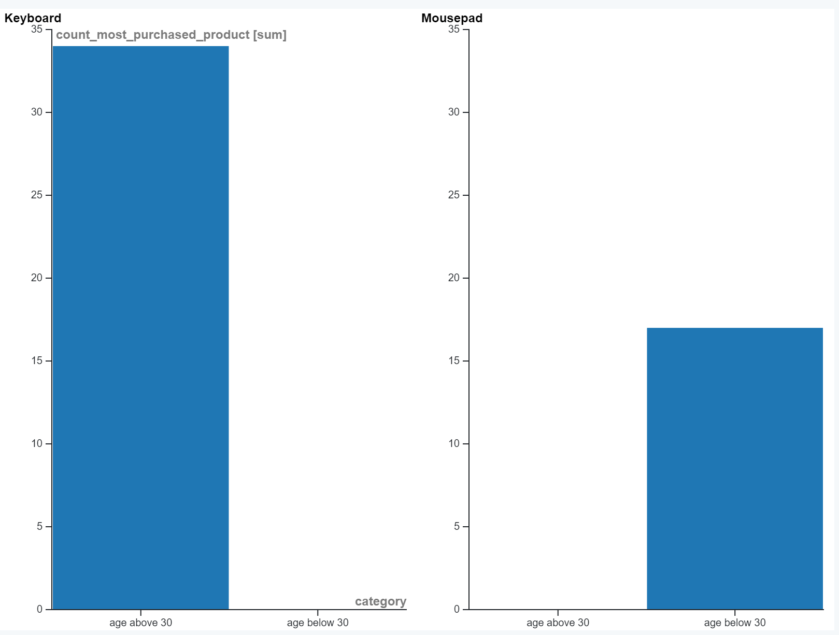

*T****he country that had minimum transactions and sales amount****.*

